Position Description
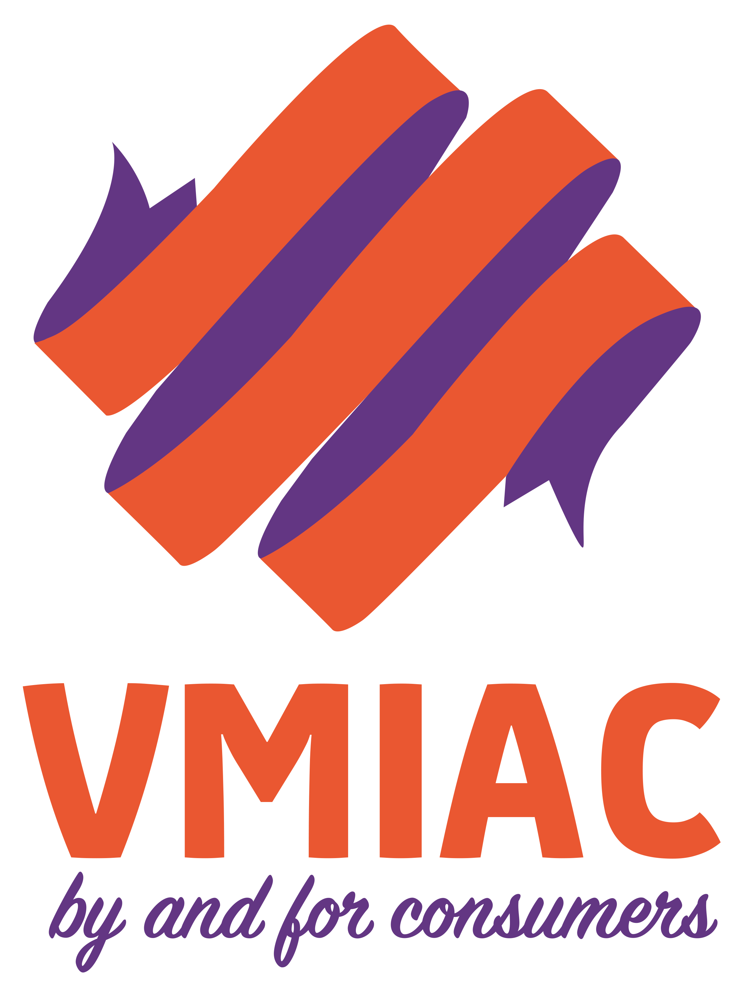
Position Title: | Membership Development Project Lead  (Limited term senior role 13-16 weeks)
Reports to: | CEO
Department: | Membership
Date | Position agreed February 2021 for commencement at the earliest possible time
Position closes | Friday 5th March 2021 at 5pm
Applications to be addressed to | Maggie.toko@vmiac.org.au
Questions | Feel free to contact Maggie with any questions you may have.

About VMIAC
VMIAC is the peak Victorian non-government organisation for people with lived experience of mental health or emotional issues.
Our vision is a world where all mental health consumers stand proud, live a life with choices honoured, rights upheld, and these principles are embedded in all aspects of society.
We provide individual, group and systemic information and advocacy along with research and evaluation, education and training.
As the peak for people with a lived experience our members are fundamental to who we are and what we do.
www.vmiac.org.au

Position overview
The Membership Development Project Lead is a three-to-four month role (13-16 weeks) with a focus on five activity areas pertaining to membership (see Key Responsibilities) and has specific responsibility for the development of the VMIAC Membership Strategy.
The short-term role is seen as being critical to VMIAC’s strategic and operational priorities and is being initiated in the context of the release of the Final Report of the Victorian Government’s Commission into Mental Health. The changes to the mental health system proposed by the Commission will require a robust and active consumer voice throughout an extended design and implementation period. VMIAC seeks to support and ensure the depth and breadth of the consumer voice and to ensure we remain deeply connected to the views and experience of our members.
In addition to developing the membership strategy, the Membership Development Project Lead will make valuable contribution to immediate improvements to VMIACs way of working with members and in contributing to designing the longer-term membership engagement and support function for the organisation. The Membership Lead will have a close working relationship with the VMIAC Royal Commission Project Officer in respect to organising and supporting related member and consumer consultations.
Additionally, the Membership Development Project Lead will provide, on an interim basis, executive support to the VMIAC Membership Sub-committee and participate as a member of the organisation’s leadership and management group.
THIS IS A LIVED EXPERIENCE POSITION
Applicants must have lived experience of mental health problems or emotional distress and of being a consumer of mental health services. Applicants must consider themselves to be work ready at a senior project level. VMIAC will work with the successful applicant, at their choice, to develop a workplace wellbeing plan to support emotional wellbeing in addition to providing regular support and supervision.
Flexible employment arrangements
This is an exciting developmental position that may be filled short-term by direct appointment or secondment or other viable contractual arrangement. The position is expected to be 0.8 to full time and work arrangements can be negotiated to be flexible. The incumbent will be eligible to apply for any ongoing role that becomes available. An attractive remuneration package applies including salary sacrifice.

ESSENTIAL SELECTION CRITERIA:
- Understanding of a membership-based organisation and experience in working with a diverse membership.
- Experience relevant to the development of organisation strategy in respect to members or other stakeholders.
- Demonstrated experience in working with consumers and from a consumer perspective including in organising and leading engagement and consultation processes.
- Knowledge and/or experience of the issues facing consumers of mental health services.
- Strong communication skills – in person and in writing.
- Experience in delivering and managing time-limited projects.
- Tertiary education in community services, community development or other relevant areas or an equivalent combination of experience, education or training.
- A current Victorian Driver's Licence and is prepared to travel for work purposes.

Preferred candidates are required to complete and/or provide Police and Working with Children checks prior to final confirmation and commencement of employment.

Desirable:
- Experience in supporting and working effectively with a sub-committee of Committee members
- Management experience and experience in working as part of a leadership and management group, including in the context of a small organisation.
- Skills in data base management and business process improvement relevant to a membership-based organisation.

Key Responsibilities
Project and professional responsibilities
The Membership Development Project Lead will:
- Develop a detailed project plan for that covers off the tasks assigned to this role (and listed below).
- Develop a comprehensive 2-3year membership strategy for VMIAC.
- Initiate early implementation of VMIAC’s Member Connect initiative which recommends on short and longer-term improvement to our relationships with members and supporting organisational processes.
- In collaboration with the organisation’s Organisation Capability Development Lead:
  - plan for the establishment of a Membership Unit with a focus on regional and rural areas and particular member cohorts (pending an increase in available resources in 2021/22).
  - develop processes and pathways for ensuring VMIACs work in research and policy is informed by the views and experience of members.
- Assist in organising and supporting consultations with members in respect to recommendations coming out of the Royal Commission and VMIACs policy development initiatives.
- Support and enable the VMIAC Volunteer Register in collaboration with relevant staff.
- Contribute content relevant to members through VMIACs digital communication platforms .
Contribution to the organisation and compliance
The Membership Project Lead will:
- Ensure compliance with regulatory and contract requirements of relevance to membership and will be aware of and adhere VMIAC policies and procedures.
- Comply with VMIAC Code of Conduct working to create a safe, supportive and happy workplace including by demonstrating awareness and understanding of diversity, culture and human rights.
- Contribute to improving the organisation’s business processes and approach to information management in ways that enhance VMIAC’s understanding of our membership, member views and preference of engagement.
- Participate in VMIAC’s management and leadership group, staff meetings and other relevant VMIAC events in person and or on-line.
- Actively contribute to Workplace Health and Safety by taking reasonable care for personal health and safety and that of others in the workplace; raising suggestions and concerns as they arise to ensure a safe work environment for employees, consumers and visitors.
- If requested by the CEO, represent VMIAC in external forums

Support and development
The CEO will provide regular supervision to the Membership Development Project Lead and additional role related support may be agreed. Development and training options relevant to the role will be negotiated.

PERFORMANCE APPRAISAL: | Performance achievement review against the project plan will be conducted monthly
TRAINING: | To be negotiated
I, (print name) acknowledge that I have read (or have had read to me) and understand the requirements of this position. I agree to work in accordance with this position description and that I understand the implications if I don’t follow the Quality Management System.
Employee Signature: ________________ Date: ____/____/____

CEO Signature: ________________ Date: ____/____/____

